**My Tim Sales**

**Description:**

My Tim is my company which supplies all bakery items and many baverages to their customers. It also provides coffees of different types containing many sizes.

For that I have created five tables having different criteria. From Expense table I have displayed expense like maintenance of machine during a week. From Cash Flow table I have displayed profit during whole week and also added filteration.

From Expense table salary is displayed in chart having different three criteria.

From Individual_Sales table coffee sales is shown with three filters.

**Screenshots of charts:**

1) 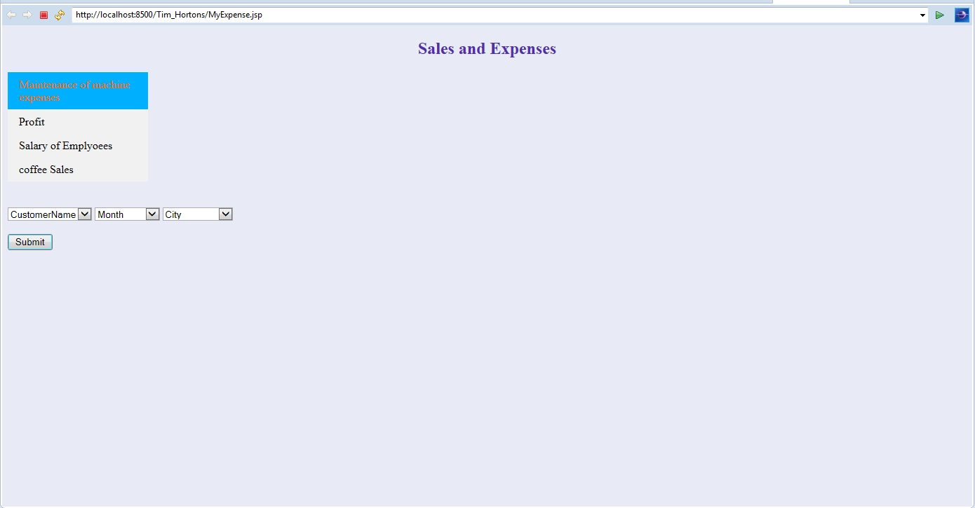

**2)** **Maintenance** **of machine**

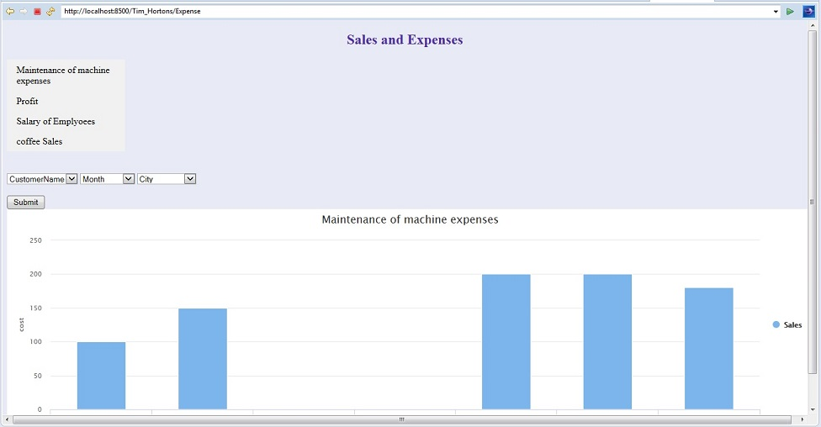

**3)Profit**

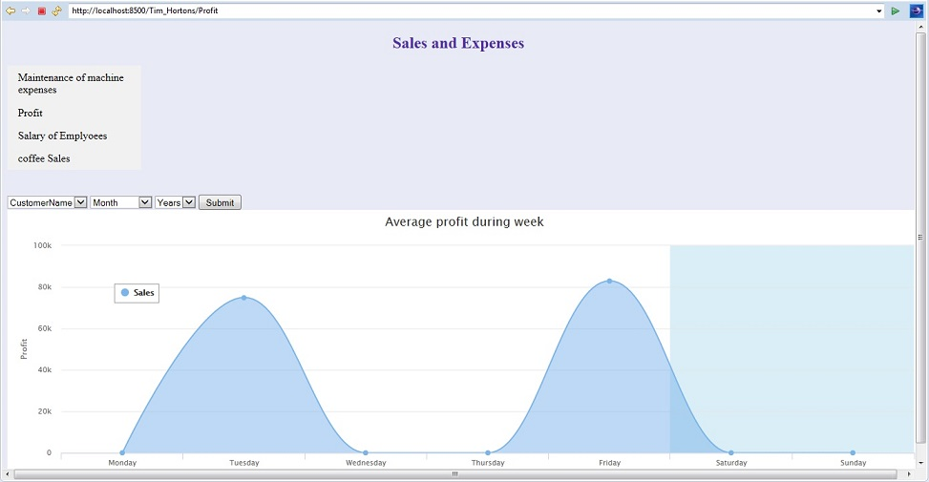

**4) Salary of Employees:**

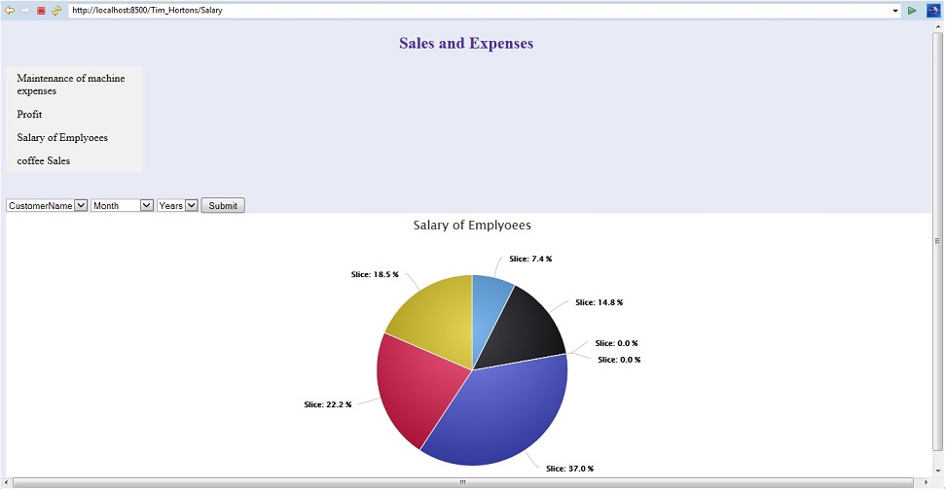

**5)Coffee Sales:**

